**Steve Dow 5/22/2018**

**Below were my notes/questions for the tutoring with Jacob before class on 5/21/2018. Jacob helped me and I thought I understood next steps to take, but I am back getting stuck again…**

**5/22/2018 New Questions/Comments:**

**(1) In the data scrape, Jacob helped me so each page would open and pull “surf location” (via a for loop). I am confused though because he used surf_location = { … which refers to a dictionary I thought, but I’m not following how/if he passed in both an index and a value for that dictionary … it does not look like he did. I thought you needed a dictionary to push to Mongo DB ?**

**(2) I used the code below to attempt to pull water and air temps within my loop**

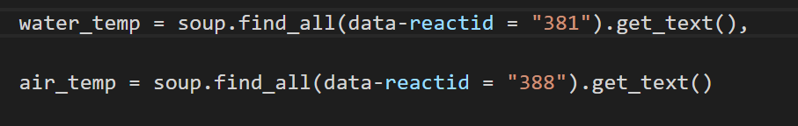

**And I could not get the file to run… It also did not mirror Jacob’s surf_location = { example, but I don’t see how I would mirror that.**

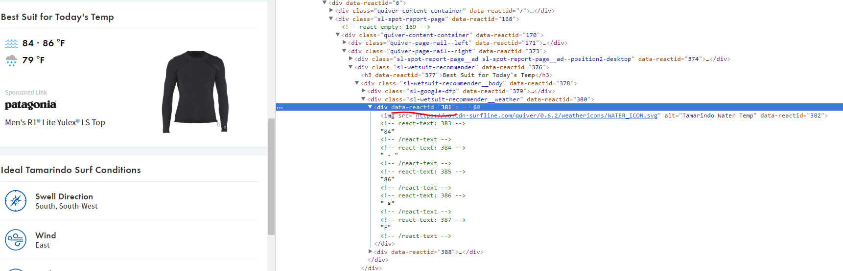

**\*\*\*\*\*\*\*\*\*\*\*\*\*\*\*\*\*\*\*\* NOTES FOR 5/21/2018 \*\*\*\*\*\*\*\*\*\*\*\*\***

**(Step 1) Scrape data from Costa Rica surf site… and store in Mongo DB database**

- Attempt 1

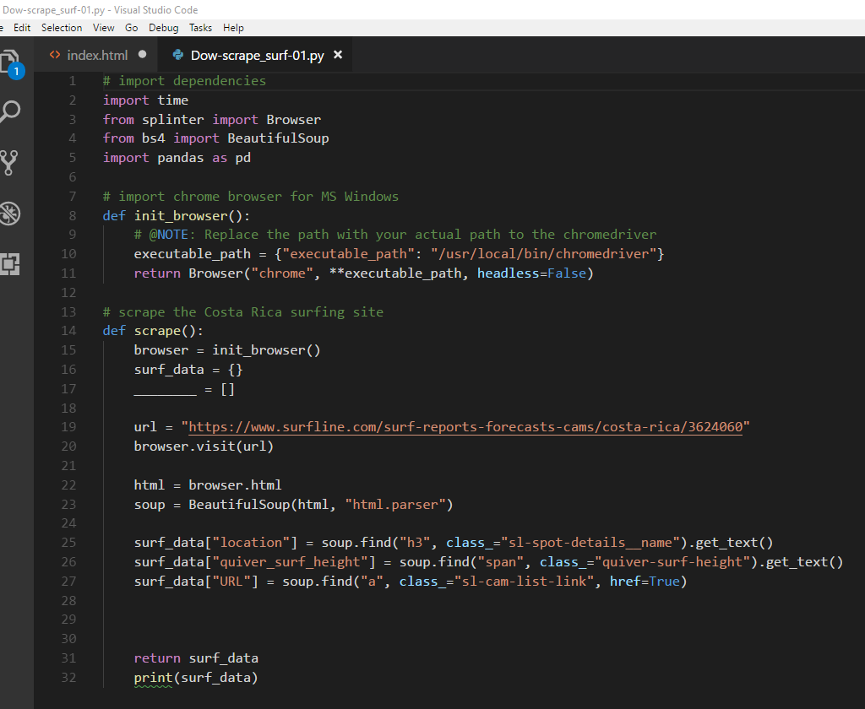

* Why is nothing actually being returned or printed when I run this program?
* Example I got this from had listings = {} and all_listing =[ ]. I’m not sure why the list is needed?
* I understand this only scrapes the data because it does not link to Mongo DB – but it SHOULD (?) be storing info in surf_data, right?... so something SHOULD be printed??
* I’m not following how to write in the code here to scrape from data on a separate url(?) so I’m currently only showing these three data collections above.

Attempt 2 -

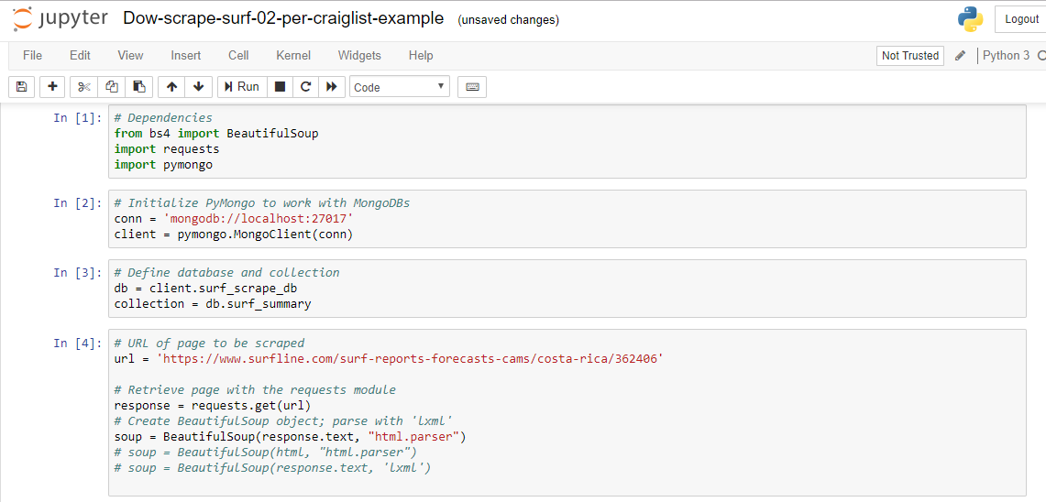

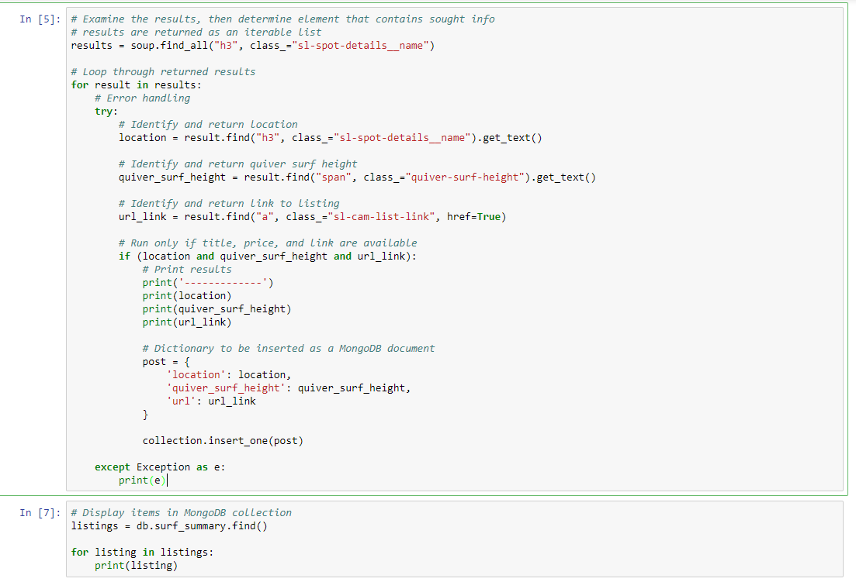

* Why is nothing actually being returned or printed when I run this program?
* I took most of this code from the craigslist example and am not getting any database to be created. It may be that no data is actually being scraped in the first place?.. or the connection to mongo DB is not working ? (I did type mongod).

**(Step 2) Create a Flask python file to pull data from the data I am supposed to have pulled**

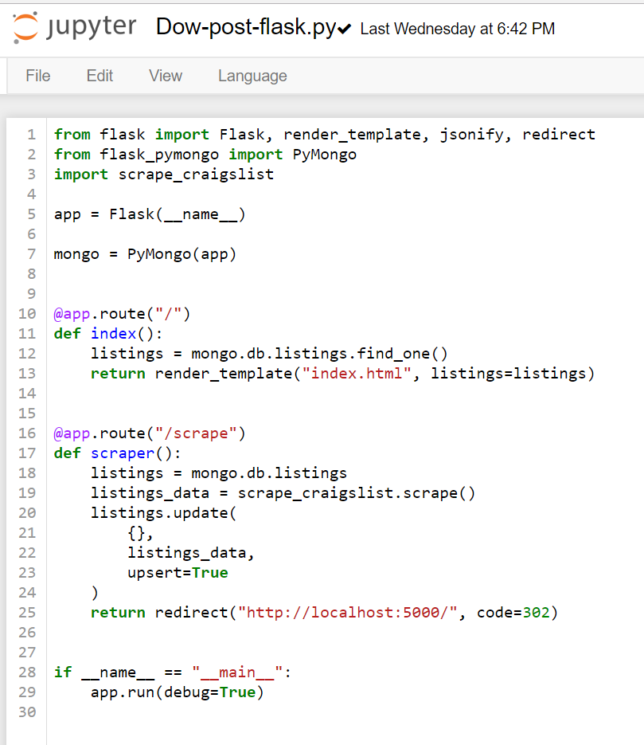

* The above file is the file from the Craigslist example. I would need to replace “Scrape_craiglist” with surf database name and “listings” with the surf database collection name???
* OR is “scrape_craigslist” a python library?? (it is being imported above)

**(Step 3) Flask connection to index file ?**

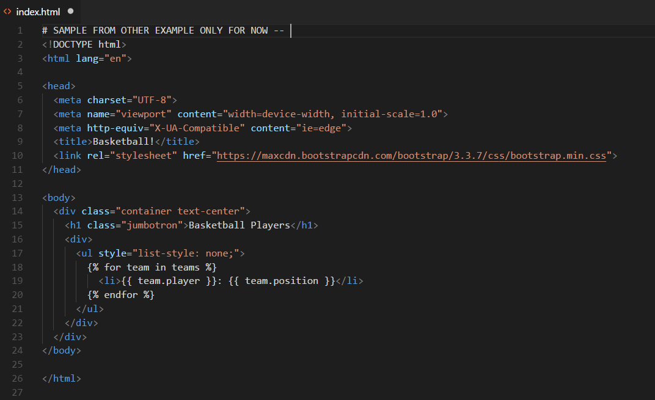

* The above is the sample index file from one of the class exercises.
* The index file should be in the templates folder.
* I’m not clear how to connect this with the flask python file.